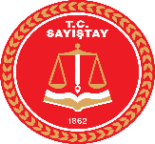
Turkish Court of Accounts

Activity: EUROSAI Emerging Issues Workshop

Date: 20th -21st November 2018

Place: Istanbul, Turkey

Participant Countries: Turkey, Finland, Austria, Estonia, Portugal, Netherlands, Poland, Spain, Czech Republic, Lithuania, United Kingdom, Sweden, European Court of Auditors, Free Trade Europa, PwC India, Aalto University
Participant(s): Emine ERSÖZ (Senior Auditor), Şeyma FIRAT (Senior Auditor)

Summary: The workshop focused on how SAIs can better be aware of emerging issues relevant to audit work. Results from the Emerging Issues web-based dialogue which was conducted in September were reviewed. The thematic areas of the workshop included digitalization, Artificial Intelligence and cyber security issues.

Photo(s):

